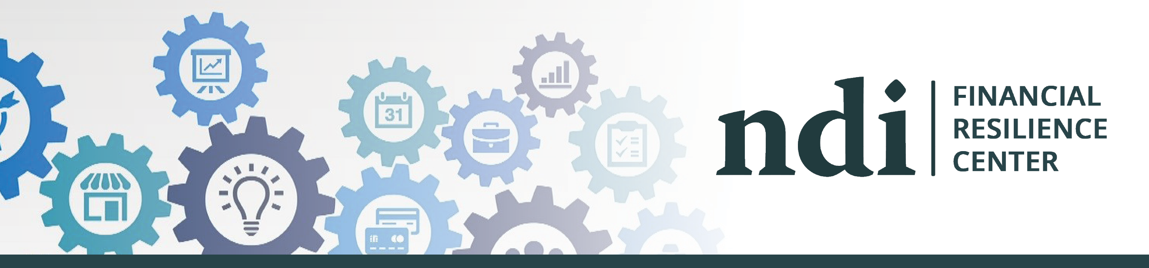
Financial Resilience Center Provides Resources to Increase Financial Stability
Financial resilience is the ability to bounce back through difficult times, emerge stronger on the other side and flourish in the “new normal.” The National Disability Institute (NDI) Financial Resilience Center is an online information hub to help people with disabilities and chronic health conditions build their financial resilience. NDI’s Financial Resilience Center answers frequently asked questions about Employment and Unemployment; Public Benefits; Housing, Food and Healthcare; Money Management; Identity Theft; and more. Provided at no cost, these resources and tips are designed to increase financial stability and reduce economic stress. Additionally, the Center’s partnership with the Association for Financial Counseling, Planning and Education® (AFCPE) provides referrals to one-on-one, virtual financial counseling or coaching, and LifeCents which offers online financial wellness training that gives personalized guidance for each individual’s situation. The Financial Resilience Center is updated frequently. Visit the Financial Resilience Center and sign up for email updates to continuously receive information on new resources and current event updates as they become available. The Financial Resilience Center was developed by National Disability Institute with generous funding from the Wells Fargo Foundation.

