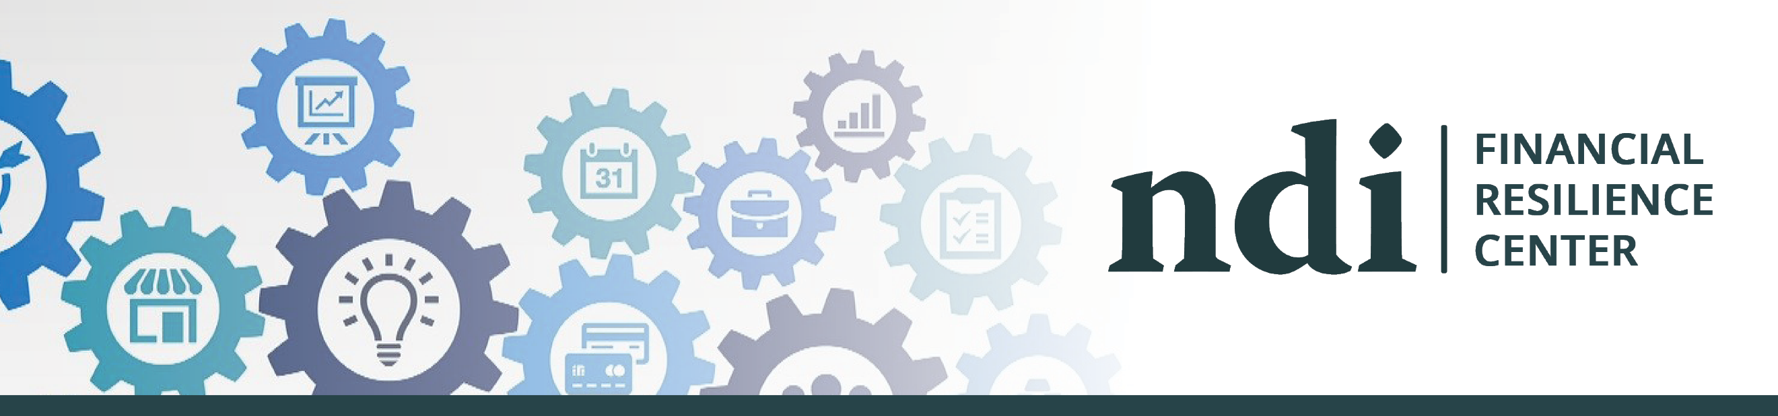

National Disability Institute’s Financial Resilience Center
Financial resilience is the ability to withstand life events that impact one's income and/or assets. The National Disability Institute (NDI) Financial Resilience Center is an online information hub to help people with disabilities and chronic health conditions build their financial resilience and bounce back through difficult times, emerging stronger on the other side and flourish. NDI’s Financial Resilience Center answers frequently asked questions about: Employment and Unemployment; Public Benefits; Money Management; Housing and Food; Health and Mental Health; Identity Theft; and more. There are also resources available in American Sign Language (ASL) for Deaf and Hard-of-Hearing individuals.
In addition to providing trusted answers to FAQs, the Financial Resilience Center offers tips, resources, and assistance to help users increase financial stability and reduce economic stress. Our partnership with the Association for Financial Counseling, Planning and Education® (AFCPE) offers virtual financial counseling and coaching, and LifeCents will provide access to online financial wellness training. These resources and assistance are offered free of cost!
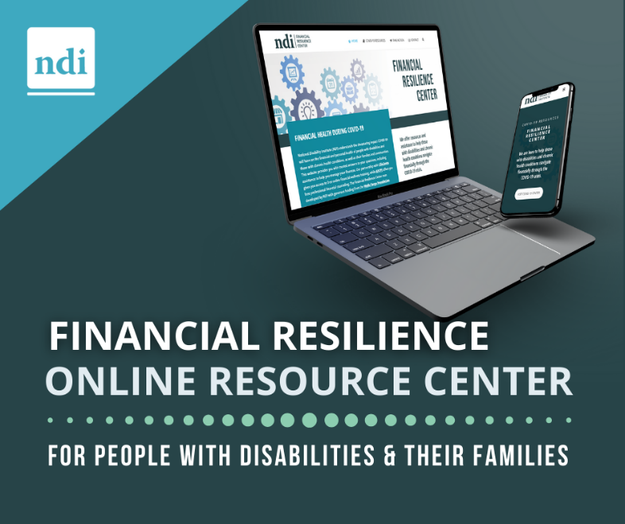
Sign up to receive email updates on new resources from the Financial Resilience Center.
The Financial Resilience Center was developed by National Disability Institute with generous funding from the Wells Fargo Foundation.

